Triangular Gyrobicupola

Definition
# Source: AI Source: Provided by: [Data Path: Persons Table -> ID Column: 1, Name_En Column: Motasem Essam] -> From: [ChatGPT] on [7/25/2026]
A Triangular Gyrobicupola is a convex polyhedron formed by joining two identical triangular cupolas along their hexagonal bases, with one cupola rotated by ${60}^{∘}$ relative to the other.
It is also known as the Cuboctahedron, one of the 13 Archimedean solids.
The rotation causes the triangular faces of one cupola to align with the square faces of the other, producing a uniform arrangement of eight equilateral triangles and six squares.

Geometric Structure
# Source: AI Source: Provided by: [Data Path: Persons Table -> ID Column: 1, Name_En Column: Motasem Essam] -> From: [ChatGPT] on [7/25/2026]
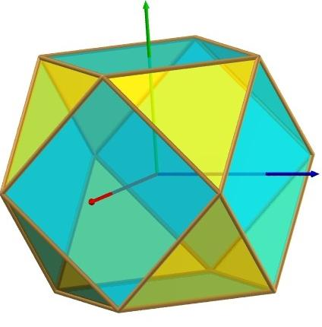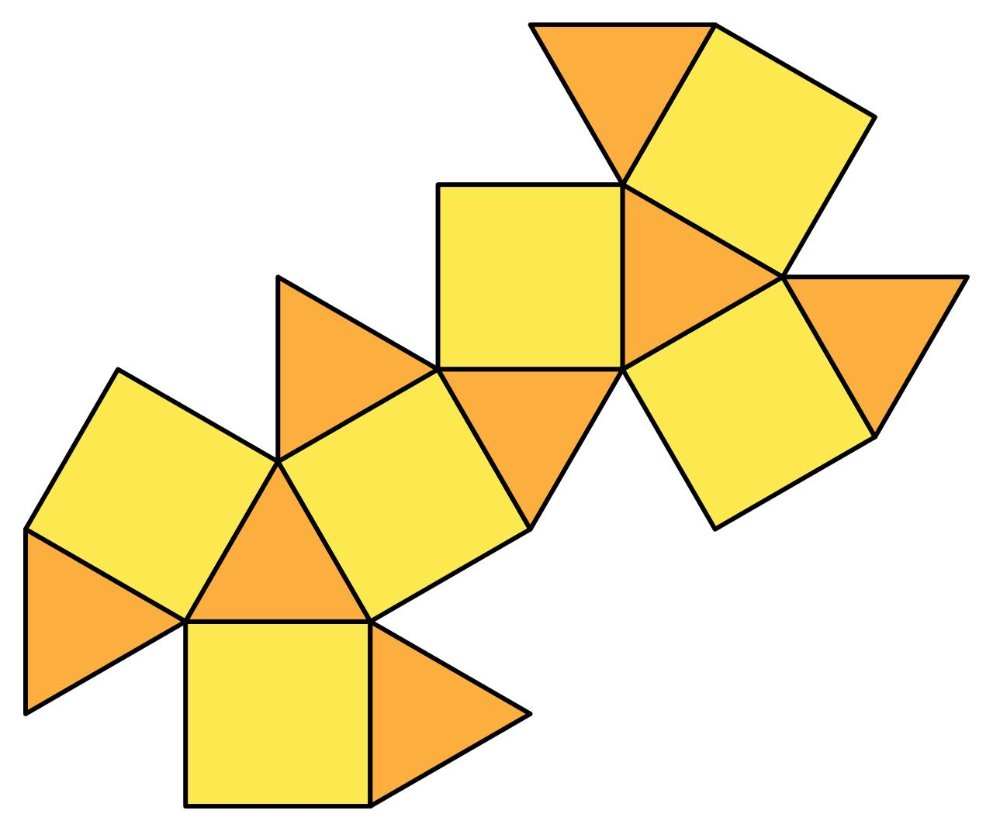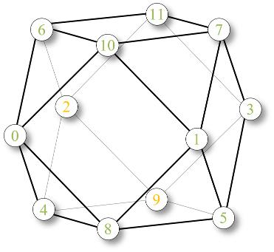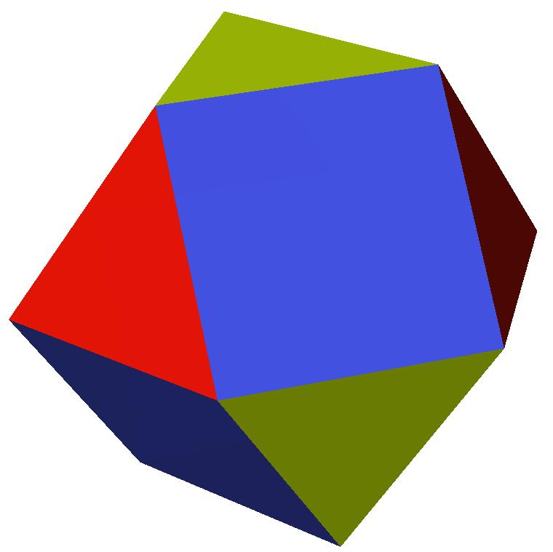
The solid consists of:
- Two opposite equilateral triangular faces.
- Six additional equilateral triangular faces.
- Six square faces.
- Twelve vertices and twenty-four edges.
The two hexagonal joining bases are internal to the construction and are not visible in the finished solid.

Face Composition
# Source: AI Source: Provided by: [Data Path: Persons Table -> ID Column: 1, Name_En Column: Motasem Essam] -> From: [ChatGPT] on [7/25/2026]
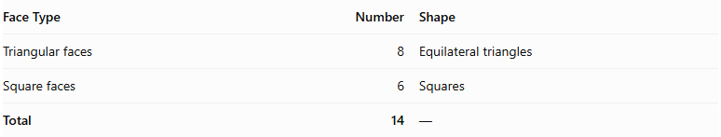
Face Type | Number | Shape
Triangular faces | 8 | Equilateral triangles
Square faces | 6 | Squares
Total | 14 | —

Mathematical Properties
# Source: AI Source: Provided by: [Data Path: Persons Table -> ID Column: 1, Name_En Column: Motasem Essam] -> From: [ChatGPT] on [7/25/2026]
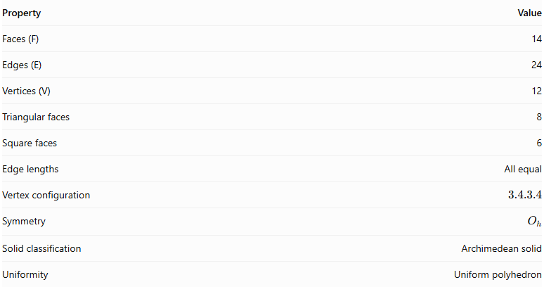
Property | Value
Faces (F) | 14
Edges (E) | 24
Vertices (V) | 12
Triangular faces | 8
Square faces | 6
Edge lengths | All equal
Vertex configuration | $$3.4.3.4$$
Symmetry | $$O_{h}$$
Solid classification | Archimedean solid
Uniformity | Uniform polyhedron
Euler's formula:
$$V-E+F=12-24+14=2$$

Surface Area
# Source: AI Source: Provided by: [Data Path: Persons Table -> ID Column: 1, Name_En Column: Motasem Essam] -> From: [ChatGPT] on [7/25/2026]
For edge length $a$:
$$S=8(\frac{\sqrt{3}}{4}a^{2})+6a^{2}$$
$$\boxed{S=(6+2\sqrt{3})a^{2}}$$

Volume
# Source: AI Source: Provided by: [Data Path: Persons Table -> ID Column: 1, Name_En Column: Motasem Essam] -> From: [ChatGPT] on [7/25/2026]
$$\boxed{V=\frac{5\sqrt{2}}{3}a^{3}}$$

Geometric Characteristics
# Source: AI Source: Provided by: [Data Path: Persons Table -> ID Column: 1, Name_En Column: Motasem Essam] -> From: [ChatGPT] on [7/25/2026]
- Convexity: It is a convex polyhedron.
- Uniformity: Every face is a regular polygon, and every vertex has the same arrangement of faces.
- Vertex configuration: Two triangles and two squares alternate around each vertex: $3.4.3.4$.
- Edge uniformity: All edges have the same length.
- Symmetry: It has octahedral symmetry, including reflection symmetry.
- Dual polyhedron: Its dual is the rhombic dodecahedron.

Construction of Triangular Gyrobicupola

Geometric Instruments Used
# Source: AI Source: Provided by: [Data Path: Persons Table -> ID Column: 1, Name_En Column: Motasem Essam] -> From: [ChatGPT] on [7/25/2026]
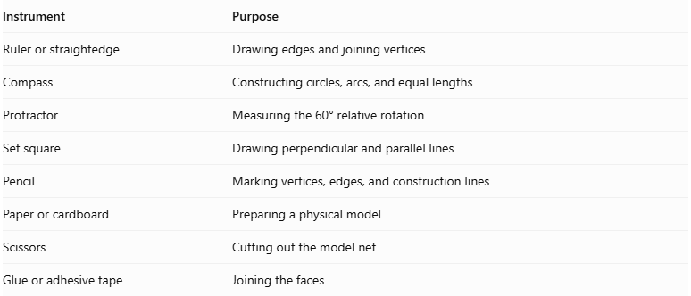
Instrument | Purpose
Ruler or straightedge | Drawing edges and joining vertices
Compass | Constructing circles, arcs, and equal lengths
Protractor | Measuring the 60° relative rotation
Set square | Drawing perpendicular and parallel lines
Pencil | Marking vertices, edges, and construction lines
Paper or cardboard | Preparing a physical model
Scissors | Cutting out the model net
Glue or adhesive tape | Joining the faces

Instrument-Based Construction Procedures

Construct the First Triangular Cupola
# Source: AI Source: Provided by: [Data Path: Persons Table -> ID Column: 1, Name_En Column: Motasem Essam] -> From: [ChatGPT] on [7/25/2026]
- Draw a regular hexagon using a compass, ruler, and protractor.
- Construct an equilateral triangle above the hexagonal base.
- Arrange the three triangular lateral faces and three square lateral faces alternately around the hexagon.
- Ensure that the triangular and square faces have matching edge lengths.
- Check that the triangular top is correctly connected to the lateral faces.

Construct the Second Triangular Cupola
# Source: AI Source: Provided by: [Data Path: Persons Table -> ID Column: 1, Name_En Column: Motasem Essam] -> From: [ChatGPT] on [7/25/2026]
- Draw another regular hexagon congruent to the first.
- Construct a congruent equilateral triangular top.
- Construct three triangular and three square lateral faces.
- Ensure that all corresponding dimensions match the first cupola.
- Keep the second cupola separate for the rotational arrangement.

Rotate the Second Cupola
# Source: AI Source: Provided by: [Data Path: Persons Table -> ID Column: 1, Name_En Column: Motasem Essam] -> From: [ChatGPT] on [7/25/2026]
- Identify the center of the shared hexagonal base.
- Mark the rotation angle:
$$α={60}^{°}$$
- Rotate the second cupola by ${60}^{°}$ around the central axis of its hexagonal base.
- Check that the two hexagonal bases remain congruent and can be matched edge-to-edge.

Join the Two Cupolas
# Source: AI Source: Provided by: [Data Path: Persons Table -> ID Column: 1, Name_En Column: Motasem Essam] -> From: [ChatGPT] on [7/25/2026]
- Place the two hexagonal bases opposite one another.
- Match the vertices and edges of the hexagons.
- Join the cupolas in the gyro arrangement.
- Ensure that the square lateral faces meet edge-to-edge around the joining region.
- Treat the shared hexagon as an internal face.
- Check that the exterior forms eight equilateral triangles and six squares.

Complete the Solid Drawing
# Source: AI Source: Provided by: [Data Path: Persons Table -> ID Column: 1, Name_En Column: Motasem Essam] -> From: [ChatGPT] on [7/25/2026]
- Draw the two exposed equilateral triangular bases at opposite ends.
- Complete the eight triangular and six square exterior faces.
- Use solid lines for visible edges.
- Use dashed lines for hidden edges when necessary.
- Verify that the final solid has 14 faces, 24 edges, and 12 vertices.
Construction restriction: This procedure uses geometric instruments, angle measurements, and geometric relationships. It does not use coordinate-based construction.

Related Geometric Solids
# Source: AI Source: Provided by: [Data Path: Persons Table -> ID Column: 1, Name_En Column: Motasem Essam] -> From: [ChatGPT] on [7/25/2026]
- Triangular Orthobicupola: The aligned version of two triangular cupolas; also called the anticuboctahedron.
- Square Gyrobicupola: A gyrobicupola formed from two square cupolas.
- Pentagonal Gyrobicupola: A gyrobicupola formed from two pentagonal cupolas.
- Cuboctahedron: The standard Archimedean-solid name for the triangular gyrobicupola.
- Rhombic Dodecahedron: The dual of the cuboctahedron.

Main Classification
# Source: AI Source: Provided by: [Data Path: Persons Table -> ID Column: 1, Name_En Column: Motasem Essam] -> From: [ChatGPT] on [7/25/2026]
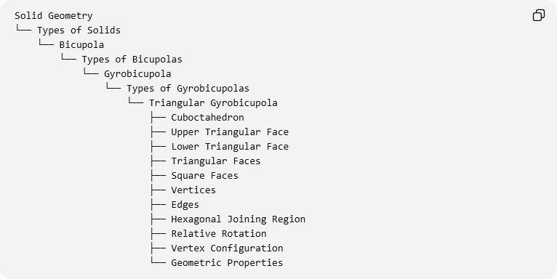
Solid Geometry
└── Types of Solids
└── Bicupola
└── Types of Bicupolas
└── Gyrobicupola
└── Types of Gyrobicupolas
└── Triangular Gyrobicupola
├── Cuboctahedron
├── Upper Triangular Face
├── Lower Triangular Face
├── Triangular Faces
├── Square Faces
├── Vertices
├── Edges
├── Hexagonal Joining Region
├── Relative Rotation
├── Vertex Configuration
└── Geometric Properties

Important Distinction
# Source: AI Source: Provided by: [Data Path: Persons Table -> ID Column: 1, Name_En Column: Motasem Essam] -> From: [ChatGPT] on [7/25/2026]
The Triangular Gyrobicupola and Triangular Orthobicupola have the same number and types of faces, edges, and vertices, but differ in the relative orientation of their cupolas.
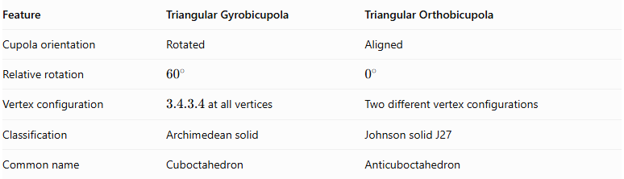
Feature | Triangular Gyrobicupola | Triangular Orthobicupola
Cupola orientation | Rotated | Aligned
Relative rotation | $${60}^{∘}$$ | $$0^{∘}$$
Vertex configuration | $3.4.3.4$ at all vertices | Two different vertex configurations
Classification | Archimedean solid | Johnson solid J27
Common name | Cuboctahedron | Anticuboctahedron

Key Points
# Source: AI Source: Provided by: [Data Path: Persons Table -> ID Column: 1, Name_En Column: Motasem Essam] -> From: [ChatGPT] on [7/25/2026]
- The triangular gyrobicupola is the cuboctahedron.
- It is formed by joining two triangular cupolas with a relative rotation of ${60}^{∘}$.
- It has 8 equilateral triangular faces and 6 square faces.
- It contains 14 faces, 24 edges, and 12 vertices.
- It is an Archimedean solid, not a Johnson solid.

Conclusion
# Source: AI Source: Provided by: [Data Path: Persons Table -> ID Column: 1, Name_En Column: Motasem Essam] -> From: [ChatGPT] on [7/25/2026]
The Triangular Gyrobicupola is a special bicupola whose rotated cupolas produce the cuboctahedron. Its alternating triangular and square faces give it the uniform vertex configuration $3.4.3.4$.

